**Graphical Abstract**

**Image**

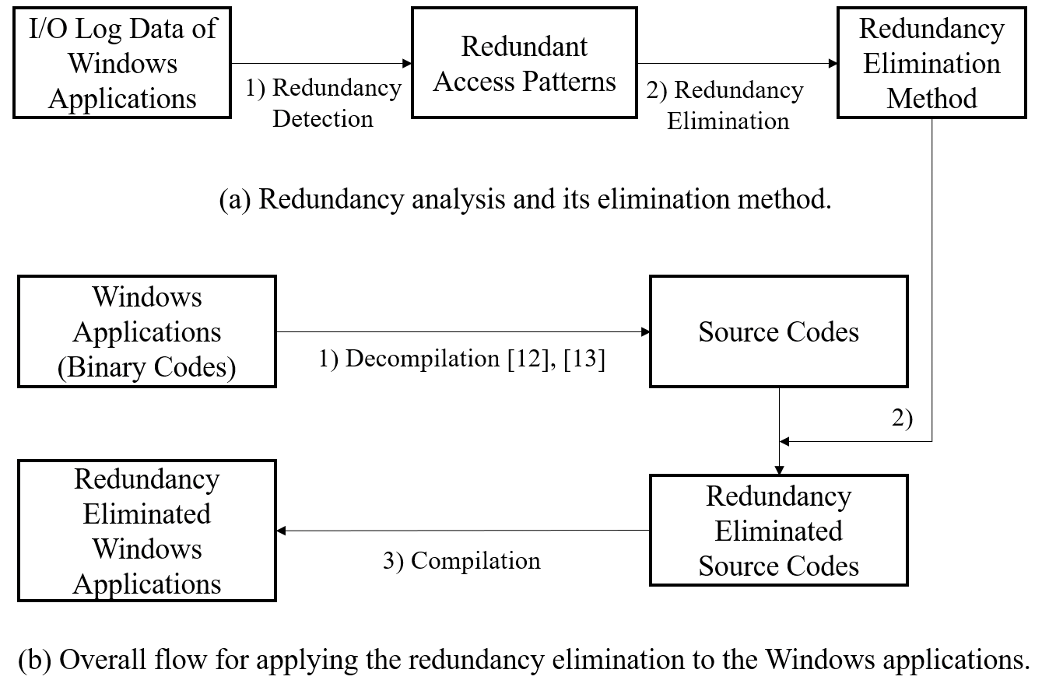

**Caption**

This figure shows the three steps for applying the redundancy elimination to the Windows applications.

1. **Decompilation**

Converting given Windows programs in binary to the source code.

1. **Redundancy Elimination**

Converting high-level source code to redundancy eliminated source code using redundancy elimination method.

1. **Compilation**

Generating Windows application without redundancy in access patterns by compiling the redundancy eliminated source code.